
Student Number
Mark /

Chemistry Assessment

Task 3 Term 2 2010 Part 1. Theory

General Instructions for Theory and Research

•Reading time 5 minutes
•Working time 100 minutes
•Write using black or blue pen
•Write your Student Number at the top of this page and those of 6,7,9 and 11.
•Board-approved calculators may be used

A data sheet and a periodic table are provided
at the back of the paper.

Total Marks – 34

Part A - 7 marks

Attempt Questions (1-7)
Allow about 10 minutes for this Part

Part B – 27 marks

Attempt Questions (8-13)
Allow about 40 minutes for this Part

Part B – 28 marks

Confidential
Keep Secure

Part A: Multiple Choice: 7 marks
Attempt Questions (1-7)
Allow about 10 minutes for this part

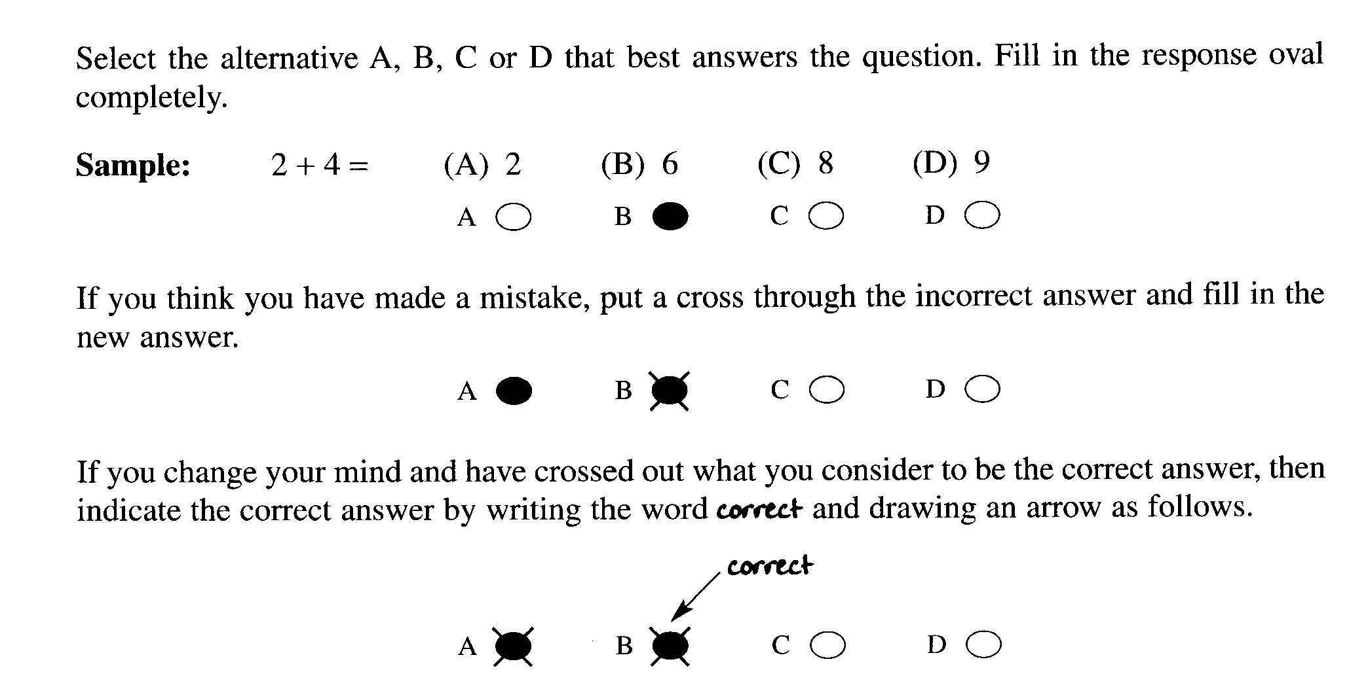

Mark your answers for the multiple choice questions on the multiple choice grid on page 6

Multiple Choice

1. Which of the following reactions does not involve coordinate covalent bonding?

(A) hydrogen ions with water molecules

(B) gaseous ammonia with gaseous HCl

(C) zinc metal with copper ions

(D) chloride ion with boron trichloride molecule

2. What is the main source of the brown haze in city centres in the morning?

(A) ozone reacting with CFCs

(B) car engines

(C) ozone reacting in the presence of sunlight

(D) dust particles stirred up by moving cars

3. What is the systematic name for an isomer of the following compound?

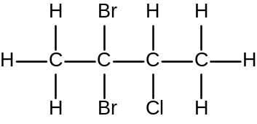

(A) 2 – chloro−3,3−dibromobutane

(B) 2,2−dibromo−3−chlorobutane

(C) 2,3–dibromo–2–chlorobutane

(D) 2–bromo–3,3–dichlorobutane

test continues next page...

4. The following gaseous equilibrium is established at high temperatures in the presence of a
finely divided nickel catalyst.

CH₄ (g) + H₂O (g) 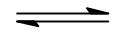 CO (g) + 3H₂ (g) ∆H = +206 kJ molL⁻¹

A particular reaction is carried out using equal amounts of CH₄ (g) and H₂O (g).
Which of the following sets of changes in conditions would lead to the greatest increase
in the proportion of the reactants converted to products?

 | Temperature | Pressure
(A) | increased | decreased
(B) | decreased | decreased
(C) | increased | increased
(D) | decreased | Increased

5. The atomic absorption spectrophotometer was developed by Sir Alan Walsh and his team
at the CSIRO in the 1950s. Its development was one of the most significant in Australian
chemical technology.

What is the advantage of using AAS ?

(A) A fast method for determining the presence of chemical pollutants in waterways.

(B) The first method for determining the concentration of cations in waterways.

(C) A method for determining very low concentration of cations.

(D) A method for determining vey low concentrations of anions in waterways.

test continues next page...

6. A 2.45 g sample of lawn fertilizer was analysed for its sulfate content by reaction with barium chloride solution. After filtration and drying, 2.18 g of barium sulfate was recovered.

What is the % (w/w) of sulfate in the lawn fertilizer ?

(A) 16.8

(B) 36.6

(C) 46.2

(D) 89.0

7. Which of the compounds below is a halon?

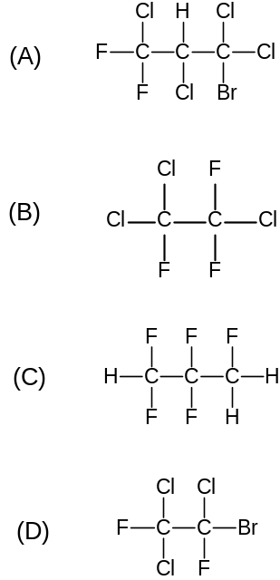

test continues next page...

Student Number …………….

Part A . Answer grid for multiple choice questions Total ................/7

1. A O B O C O D O

2. A O B O C O D O

3. A O B O C O D O

4. A O B O C O D O

5. A O B O C O D O

6. A O B O C O D O

7. A O B O C O D O

Total: ……………../7

test continues next page
Student Number ………….
Part B Free Response Questions

Attempt Questions 8-13
Allow about 40 minutes for this part

Show all relevant working in questions involving calculations.

Question 8 (4 marks) MARKS

Draw the Lewis electron dot diagram of ozone and the oxygen molecule, and explain
the difference in their reactivity in terms of their structure and/or bonding. 4

Ozone | Oxygen molecule

..................................................................................................................................................................

.................................................................................................................................................................

.................................................................................................................................................................

.................................................................................................................................................................

.................................................................................................................................................................

. ...............................................................................................................................................................

.................................................................................................................................................................

.................................................................................................................................................................

test continues next page

MARKS

Question 9 (4 mark) 4

Biochemical oxygen demand is a water quality indicator. Considering this particular
indicator, assess the effectiveness and practicality of microscopic membrane filters in
purifying and sanitising mass water supplies.

....................................................................................................................................................................

....................................................................................................................................................................

....................................................................................................................................................................

....................................................................................................................................................................

....................................................................................................................................................................

.....................................................................................................................................................................

....................................................................................................................................................................

....................................................................................................................................................................

....................................................................................................................................................................

test continues next page

Student Number ………….

MARKS
Question 10 (4 marks)

The production of ammonia from nitrogen and hydrogen is given by the equation.

3H₂ (g) + N₂ (g) 2NH₃ (g) + heat

 | Concentration of species at 500⁰C
 | [H₂]  (molL⁻¹) | [N₂]  (molL⁻¹) | [NH₃]  (molL⁻¹)
Initial | 1.542 | 0.881 | 0.000
Equilibrium |  |  | 0.281

(a) Write the equilibrium expression for the reaction. 1

..............................................................................................................................................

(b) Calculate the equilibrium concentrations of N₂ and H₂ under these conditions. 2

...............................................................................................................................................

...............................................................................................................................................

(c) Calculate the value of K for the reaction. 1

...............................................................................................................................................

...............................................................................................................................................

................................................................................................................................................

.................................................................................................................................................

test continues next page

MARKS

Question 11 (4 marks) 4

Outline the steps used industrially to maximize the rate and yield of sulfur trioxide from
sulfur dioxide. Include a balanced equation in your answer.

............................................................................................................................................................

............................................................................................................................................................

.............................................................................................................................................................

.............................................................................................................................................................

..............................................................................................................................................................

..............................................................................................................................................................

..............................................................................................................................................................

...............................................................................................................................................................

test continues next page…

Student Number ………….

MARKS

Question 12 (6 marks) 6

Water samples from oyster farms are regularly checked for lead ion contamination using AAS.
Outline how the concentration of lead ions in the water can be determined using AAS. Include a
labeled schematic diagram of the AAS instrumentation.

……………………………………………………………………………………………………………...

……………………………………………………………………………………………………………...

……………………………………………………………………………………………………………..

……………………………………………………………………………………………………………..

……………………………………………………………………………………………………………..

……………………………………………………………………………………………………………..

……………………………………………………………………………………………………………..

……………………………………………………………………………………………………………..

……………………………………………………………………………………………………………..

……………………………………………………………………………………………………………..

……………………………………………………………………………………………………………..

……………………………………………………………………………………………………………..

……………………………………………………………………………………………………………..

……………………………………………………………………………………………………………..

……………………………………………………………………………………………………………..

……………………………………………………………………………………………………………..

……………………………………………………………………………………………………………..

……………………………………………………………………………………………………………..

……………………………………………………………………………………………………………..

test continues next page…..

MARKS

Question 13 (5 marks) 5

Use a flow chart to show the separation of a mixture consisting of CO₃²⁻, PO₄³⁻ and Cl⁻.
Include in your flow chart the reagent(s) required and the observable result for each ion.

End of Theory Test

